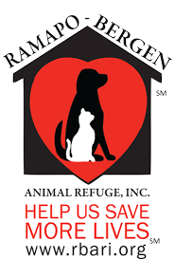
Click or tap here to enter text. AWARD PROJECT
Troop # Click or tap here to enter text.

Please help feed our friends!

We are working on our Click or tap here to enter text. and need your help!
As part of our project we are collecting food and other donations for
RAMAPO-BERGEN ANIMAL REFUGE, INC.
RBARI is a great organization working to improve the lives of many abandoned and abused animals

RBARI’s mission is founded on the belief that all animals have a natural right to humane treatment including proper care and safe shelter

Please consider donating items form their Wish List at https://rbari.org/donate/wishlist.html

THANK YOU FOR YOUR SUPPORT!

